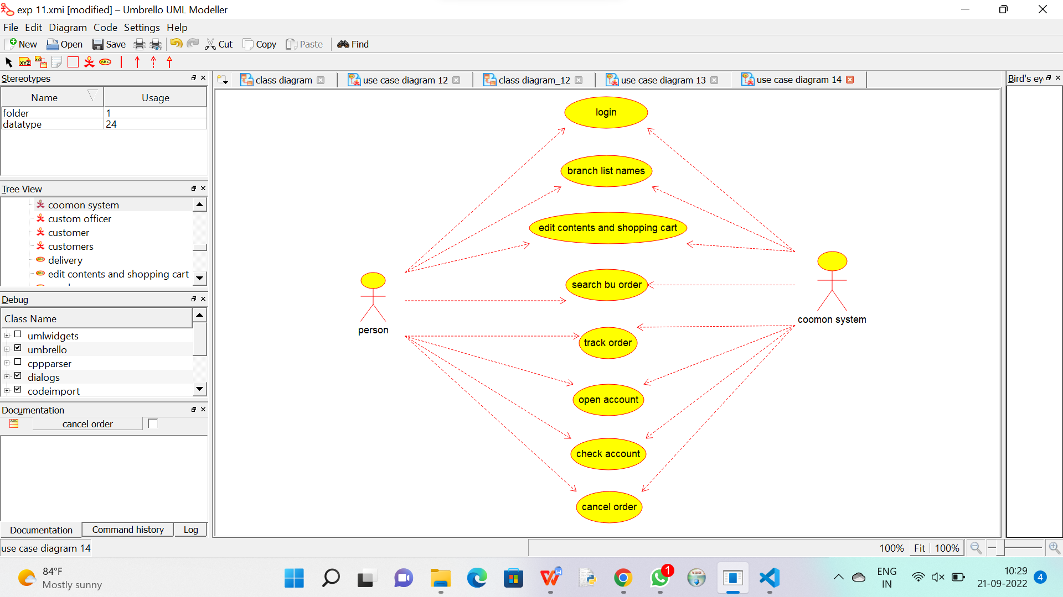

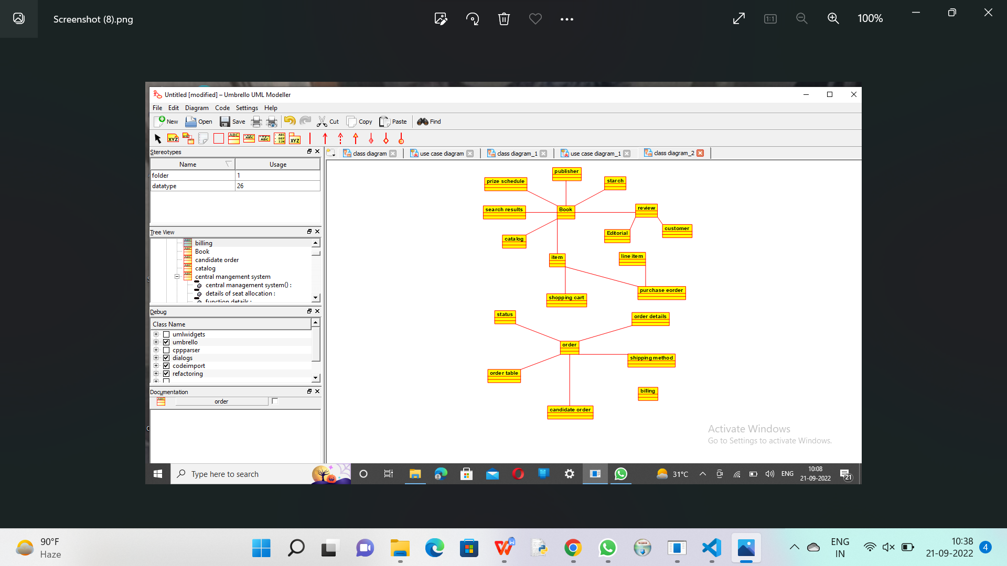

Code for new class :

/**

 * Class new_class

 */

public class new_class {

  //

  // Fields

  //

  //

  // Constructors

  //

  public new_class () { };

  //

  // Methods

  //

  //

  // Accessor methods

  //

  //

  // Other methods

  //

}

Code for central mag sys :

**

 * Class central_management_system

 */

public class central_management_system {

  //

  // Fields

  //

  private void store_details;

  private void verify_details;

  private void verify_;

  private void enroll_;

  //

  // Constructors

  //

  public central_management_system () { };

  //

  // Methods

  //

  //

  // Accessor methods

  //

  /**

   * Set the value of store_details

   * @param newVar the new value of store_details

   */

  private void setStore_details (void newVar) {

    store_details = newVar;

  }

  /**

   * Get the value of store_details

   * @return the value of store_details

   */

  private void getStore_details () {

    return store_details;

  }

  /**

   * Set the value of verify_details

   * @param newVar the new value of verify_details

   */

  private void setVerify_details (void newVar) {

    verify_details = newVar;

  }

  /**

   * Get the value of verify_details

   * @return the value of verify_details

   */

  private void getVerify_details () {

    return verify_details;

  }

  /**

   * Set the value of verify_

   * @param newVar the new value of verify_

   */

  private void setVerify_ (void newVar) {

    verify_ = newVar;

  }

  /**

   * Get the value of verify_

   * @return the value of verify_

   */

  private void getVerify_ () {

    return verify_;

  }

  /**

   * Set the value of enroll_

   * @param newVar the new value of enroll_

   */

  private void setEnroll_ (void newVar) {

    enroll_ = newVar;

  }

  /**

   * Get the value of enroll_

   * @return the value of enroll_

   */

  private void getEnroll_ () {

    return enroll_;

  }

  //

  // Other methods

  //

}

Code for management system :

/**

 * Class trading_management_system

 */

public class trading_management_system {

  //

  // Fields

  //

  private void verify_product;

  private void amount;

  private void transport;

  private void delivery_product;

  private void money_transfer_;

  //

  // Constructors

  //

  public trading_management_system () { };

  //

  // Methods

  //

  //

  // Accessor methods

  //

  /**

   * Set the value of verify_product

   * @param newVar the new value of verify_product

   */

  private void setVerify_product (void newVar) {

    verify_product = newVar;

  }

  /**

   * Get the value of verify_product

   * @return the value of verify_product

   */

  private void getVerify_product () {

    return verify_product;

  }

  /**

   * Set the value of amount

   * @param newVar the new value of amount

   */

  private void setAmount (void newVar) {

    amount = newVar;

  }

  /**

   * Get the value of amount

   * @return the value of amount

   */

  private void getAmount () {

    return amount;

  }

  /**

   * Set the value of transport

   * @param newVar the new value of transport

   */

  private void setTransport (void newVar) {

    transport = newVar;

  }

  /**

   * Get the value of transport

   * @return the value of transport

   */

  private void getTransport () {

    return transport;

  }

  /**

   * Set the value of delivery_product

   * @param newVar the new value of delivery_product

   */

  private void setDelivery_product (void newVar) {

    delivery_product = newVar;

  }

  /**

   * Get the value of delivery_product

   * @return the value of delivery_product

   */

  private void getDelivery_product () {

    return delivery_product;

  }

  /**

   * Set the value of money_transfer_

   * @param newVar the new value of money_transfer_

   */

  private void setMoney_transfer_ (void newVar) {

    money_transfer_ = newVar;

  }

  /**

   * Get the value of money_transfer_

   * @return the value of money_transfer_

   */

  private void getMoney_transfer_ () {

    return money_transfer_;

  }

  //

  // Other methods

  //

}